

**DEPARTMENT OF ARTIFICIAL INTELLIGENCE AND MACHINE LEARNING**

**(*Accredited by NBA*)**

**MANGALORE INSTITUTE OF TECHNOLOGY & ENGINEERING**

*Accredited by NAAC with A+ Grade, An ISO 9001: 2015 Certified Institution*  (*A Unit of Rajalaxmi Education Trust®, Mangalore - 575001*) Affiliated to VTU, Belagavi, Approved by AICTE, New Delhi

**Badaga Mijar, Moodabidri-574225, Karnataka**

**2022-23**

**Project on**

# “CROSS-WORD PUZZLE GENERATOR”

### By

**AMOGHA ACHARYA 4MT21AI006**

**N SHREYAS NAYAK 4MT21AI032 NISHMITHA 4MT21AI035**

### SOUJANYA 4MT21AI054

**DHANUSH SHETTY 4MT21AI018**

# ABSTRACT

Crossword puzzles are a popular word game enjoyed by people of all ages. This abstract presents a Crossword Puzzle Generator program implemented in the C programming language. The program allows users to create customized crossword puzzles effortlessly.

The primary objectives of this program are as follows:

1. User Input: The program starts by taking user input for the crossword puzzle's dimensions, i.e., the number of rows and columns. Users also provide words and clues to be included in the puzzle.

2. Puzzle Generation: Based on the user's input, the program generates an empty crossword grid, ensuring that words intersect at specific letters, creating the classic crossword structure. It uses algorithms to position words optimally, taking into account the provided words and clues.

3. Word Placement: The program efficiently fits words into the grid, ensuring minimal overlap and maximum utilization of the available space. It also verifies that the provided words can be placed within the specified dimensions.

4. Clue Assignment: Each word placed in the grid is associated with a corresponding clue provided by the user. The program ensures that clues are correctly matched with their respective words.

5. Puzzle Rendering: Once the crossword grid is populated and clues are assigned, the program renders the puzzle for the user to solve. The grid is displayed with numbered cells, and clues are presented in a user-friendly format.

6. User Interaction: Users can interact with the generated crossword puzzle by inputting their answers, and the program checks the correctness of their solutions.

7. Solution Verification: The program includes a solution verification feature to assess whether the user's input matches the correct solution.Users have the option to print the crossword puzzle or save it in a file for later use or sharing.

8. Error Handling: The program incorporates error-handling mechanisms to address invalid inputs, such as incompatible word lengths or grid dimensions. It provides a user-friendly command-line interface, making it accessible to individuals with varying levels of programming experience.

This Crossword Puzzle Generator program in C aims to provide a versatile and efficient tool for crossword enthusiasts, educators, and puzzle creators to generate, share, and solve custom crossword puzzles. Its implementation involves careful consideration of grid layout, word placement, and user interaction to create engaging and challenging puzzles.

# INTRODUCTION

Crossword puzzles are a popular form of word games that challenge the minds of people of all ages. They are not only entertaining but also a great way to improve vocabulary and cognitive skills. In this C programming tutorial, we will delve into the fascinating world of crossword puzzles and learn how to create a simple crossword puzzle generator program.

A crossword puzzle generator is a computer program that automates the process of creating crossword puzzles. It takes a set of words and clues as input and arranges them into a grid such that the words intersect at certain letters, creating a challenging puzzle for users to solve. This program will allow us to define our own word list and generate custom crossword puzzles effortlessly.

Key Concepts and Goals:

Word List: We will maintain a list of words along with their corresponding clues. This list serves as the input data for our crossword puzzle generator.

Grid Generation: The program will create an empty grid, determining the size based on the words provided. It will then strategically place the words into the grid, ensuring they intersect at specific letters.

User Interaction: We'll include features for users to input words and clues, generate the crossword puzzle, and interactively solve it.

Learning to create a crossword puzzle generator program in C offers several benefits:

1. Algorithmic Thinking: It sharpens your problem-solving skills as you devise algorithms to arrange words within the grid.

2. C Language Skills: It reinforces your understanding of the C programming language, including arrays, strings, and file handling.

3. Creativity: You have the freedom to create your own custom crossword puzzles, allowing for creativity and personalization.

4. Educational Value: You can use the generated puzzles for educational purposes, such as teaching vocabulary or as brain-teasers.

# TECHNOLOGIES USED

Creating a crossword puzzle generator program using C code involves a combination of data structures, algorithms, and libraries. Here are some of the key technologies and concepts typically used in such a program:

1. C Programming Language: The program itself is written in the C programming language, which is well-suited for low-level memory manipulation and efficient algorithms.

2. Data Structures: You would use various data structures to represent and manipulate the crossword grid, words, and their positions. Common data structures include arrays, matrices, linked lists, and trees.

3. Randomization: You need a way to generate random crossword puzzles. You can use C's standard library functions like `rand()` and `srand()` for random number generation.

4. File I/O: To read word lists or dictionaries and save generated crossword puzzles, you'll use file input and output functions in C, such as `fopen()`, `fclose()`, `fread()`, and `fwrite()`.

5. String Manipulation: C provides string manipulation functions like `strcpy()`, `strlen()`, and `strcat()` for working with words and clues.

6. Algorithm for Puzzle Generation: Creating an algorithm to generate crossword puzzles is a key component. Common approaches include backtracking algorithms, which recursively fill the crossword grid with words and validate the placement.

7. User Interface: If you want to create a user-friendly interface, you can use C libraries like ncurses or graphical libraries like GTK or SDL to create a text-based or graphical interface for users to interact with the program.

8. Word Lists or Dictionaries: You'll need a source of words to use in your crossword puzzles. This can be a text file containing a list of words or a more extensive dictionary. Implement proper error handling mechanisms to deal with issues like file I/O errors or incorrect user input.

9.Crossword Puzzle Rendering: If you want to display the generated crossword puzzle, you may need to implement rendering logic using ASCII characters or integrate with external libraries for graphical rendering.

10. Testing and Debugging Tools: Debugging tools like GDB and testing frameworks can help ensure the program works correctly. Proper memory management techniques should be applied to avoid memory leaks and optimize memory usage.

Creating a crossword puzzle generator in C can be a complex project, depending on the level of sophistication and user-friendliness you desire. You may need to leverage additional libraries **or tools based on your specific requirements**

# SYSTEM ARCHITECTURE

Creating a crossword puzzle generator program in C involves several architectural considerations. Here, I'll outline a high-level system architecture for a simple crossword puzzle generator program using C:

1. User Interface:

- The user interface component interacts with the user to collect preferences, such as grid size, word list, and any specific words they want to include.

2. Input Processing:

- This component processes user input, validates it, and prepares it for use in the puzzle generation algorithm. It may include error checking and data validation.

3. Puzzle Generator Algorithm:

- This is the core of the crossword puzzle generator. It takes the input data, including the word list and grid size, and creates a crossword puzzle grid. The algorithm should consider word placement, word intersections, and grid constraints.

4. Grid Data Structure:

- The grid data structure holds the crossword puzzle grid. It should represent the grid cells, their positions, and the letters in each cell. You may use a multi-dimensional array or a custom data structure.

5. Word List Management:

- This component manages the list of words to be used in the crossword. It should provide methods for adding, removing, and selecting words based on user preferences.

6. Grid Rendering:

- The rendering component takes the crossword grid data and displays it to the user. It may use ASCII characters or a graphical user interface, depending on your program's complexity.

7. Solution Validation:

- After generating the puzzle, you need a component to validate the solution. Ensure that all words fit correctly and intersect as required.

8. Error Handling:

- Implement error handling mechanisms to catch and handle any issues that may arise during puzzle generation, such as unplaceable words or conflicting constraints.

9. Data Persistence (Optional):

- If you want to allow users to save or load puzzles, you might include data persistence components for saving puzzle state and retrieving it later.

10. Randomization:

- If your crossword puzzle generator includes a randomization feature, consider arandomization component that shuffles word list or adjusts the placement of words in the grid.

11. File I/O (Optional):

- If you want to allow users to save puzzles to files or load puzzles from files, implement file input/output components.

12. Testing and Debugging Tools:

- Develop debugging and testing tools to help identify and fix issues in the crossword puzzle generation process.

13. Performance Optimization:

- Depending on the complexity of your puzzle generator, consider performance optimization techniques to make puzzle generation efficient, especially for large grids.

14. User Feedback and Interaction:

- Throughout the process, provide user feedback and interaction to make the puzzle creation experience intuitive and enjoyable.

15. Documentation and Help:

- Include documentation and help features to guide users on how to use the program effectively.

16. Dependencies and Libraries:

- Identify any external libraries or dependencies required for your program, such as GUI libraries or data structures.

17. Platform Considerations:

- Ensure that your program can run on the target platforms (e.g., Windows, Linux) and consider portability issues.

18. Error Reporting and Logging:

- Implement mechanisms for reporting errors to the user and logging for debugging purposes.

# DESIGN AND IMPLEMENTATION

Creating a crossword puzzle generator program in C involves several steps, including designing data structures, implementing algorithms, and handling input/output. Here's a high-level design and implementation outline for a simple crossword puzzle generator program:

**Design:**

1. Data Structures:

- Define data structures to represent the crossword grid, including cells (black and white), words, and clues.

- Use a 2D array to represent the crossword grid. Each cell can be either black (no entry) or white (entry allowed).

2. Word Database:

- Maintain a database of words of varying lengths.

- Categorize words by length for easy selection during puzzle generation.

3. Puzzle Generation Algorithm:

- Use a backtracking algorithm to place words onto the grid.

- Start with an empty grid and iterate through word lengths, selecting words from the database that fit the available space.

- Try placing a word horizontally and vertically, choosing the option that results in fewer conflicts.

- If a conflict occurs, backtrack and try a different word.

4. Clue Generation:

- Generate clues for each word based on its position in the grid.

- Clues can be simple definitions, synonyms, or cryptic clues, depending on the complexity of the puzzle.

5. User Interface:

- Create a user-friendly interface for input and output.

- Allow users to specify grid dimensions, difficulty level, and preferred word sources.

**CODE:**

#include <stdio.h>

#include <stdlib.h>

#include <time.h>

#include <string.h>

typedef struct {

char* word;

char* clue;

} WordCluePair;

WordCluePair getWordAndClue(int difficulty) {

WordCluePair easyPairs[5] = {

{ "copy", "Duplicate" },

{ "house", "Place to live" },

{ "chair", "Furniture item" },

{ "book", "Reading material" },

{ "lamp", "Source of light" }

};

WordCluePair mediumPairs[5] = {

{ "register", "Enroll" },

{ "coding", "Programming" },

{ "workshop", "Educational event" },

{ "safeguard", "Protection measure" },

{ "beauty", "Aesthetic appeal" }

};

WordCluePair hardPairs[5] = {

{ "exams", "Tests" },

{ "challenging", "Demanding" },

{ "encryption", "Data security" },

{ "algorithm", "Problem-solving approach" },

{ "complexity", "Degree of difficulty" }

};

WordCluePair* selectedPairs;

int numPairs;

switch (difficulty) {

case 1:

selectedPairs = easyPairs;

numPairs = 5;

break;

case 2:

selectedPairs = mediumPairs;

numPairs = 5;

break;

case 3:

selectedPairs = hardPairs;

numPairs = 5;

break;

default:

selectedPairs = easyPairs;

numPairs = 5;

break;

}

int index = rand() % numPairs;

return selectedPairs[index];

}

int main() {

char name[100];

printf("Enter Name: ");

scanf("%s", name);

printf("\n");

int score = 0;

char input;

int difficulty;

do {

system("cls");

printf("************************************CROSSWORD PUZZLE************************************\n");

printf("Select Difficulty Level:\n");

printf("1. Easy\n");

printf("2. Medium\n");

printf("3. Hard\n");

printf("Enter your choice (1/2/3): ");

scanf("%d", &difficulty);

srand(time(NULL));

WordCluePair selectedPair = getWordAndClue(difficulty);

char* selectedWord = selectedPair.word;

char* clue = selectedPair.clue;

char puzzle[9][9];

int i, j;

for (i = 0; i < 10; i++) {

for (j = 0; j < 10; j++) {

do {

puzzle[i][j] = rand() % 26 + 'a';

} while (!(puzzle[i][j] >= 'a' && puzzle[i][j] <= 'z'));

}

}

int r, c;

if (strlen(selectedWord) % 2 != 0) {

r = rand() % 10;

c = rand() % 1;

int x;

for (x = 0; selectedWord[x] != '\0'; x++, c++) {

puzzle[r][c] = selectedWord[x];

}

} else {

r = rand() % 2;

c = rand() % 10;

int x;

for (x = 0; selectedWord[x] != '\0'; x++, r++) {

puzzle[r][c] = selectedWord[x];

}

}

printf("\nClue: %s\n", clue);

printf("\n");

for (i = 0; i < 10; i++) {

for (j = 0; j < 10; j++) {

printf("%c ", puzzle[i][j]);

}

printf("\n");

}

char answer[100];

printf("\nEnter word that is of length %lu\n", strlen(selectedWord));

scanf("%s", answer);

if (strcmp(answer, selectedWord) == 0) {

score = score + 1;

printf("You won!!!\n");

} else {

printf("You lost!!!\n");

}

printf("Play again? (y/n)");

scanf(" %c", &input);

} while (input != 'n');

printf("****************************GAME OVER****************************\n");

printf("%s\nYour score is: %d\n\n\n\n", name, score);

return 0;

}

**OUTPUT:**

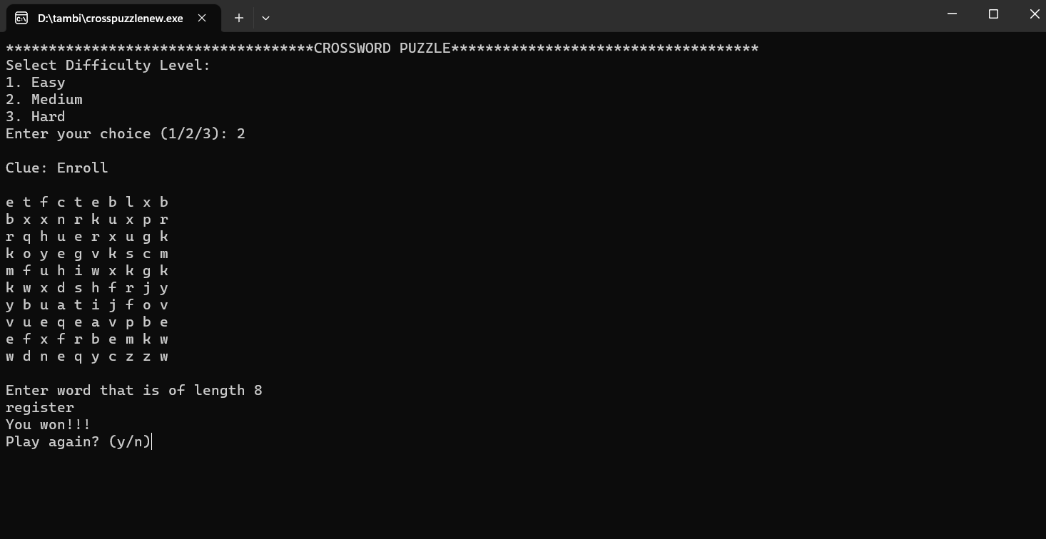

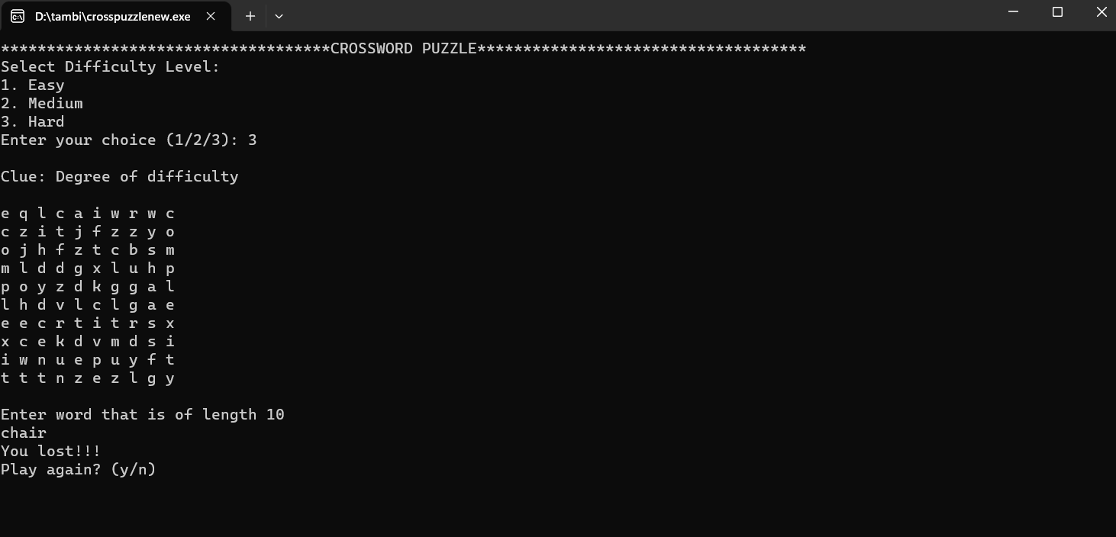

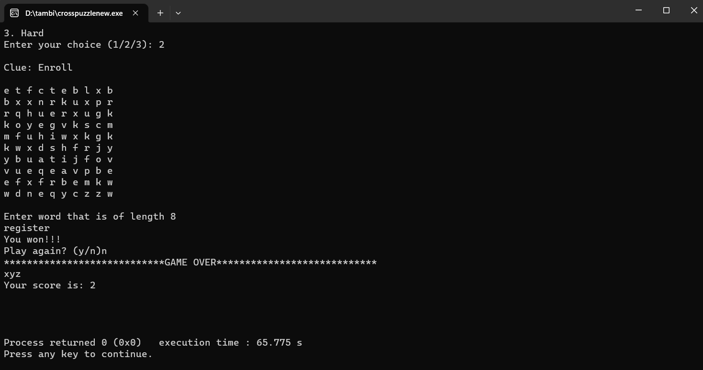

**MINDMAP:**

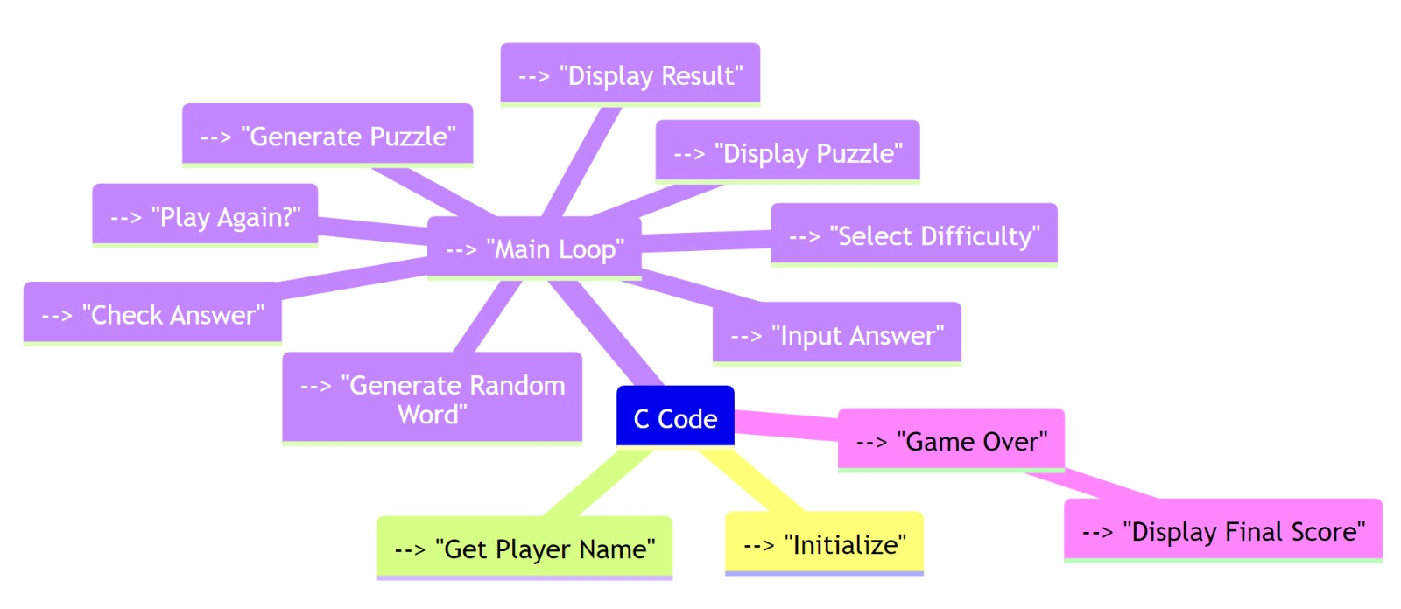

**FLOWCHART:**

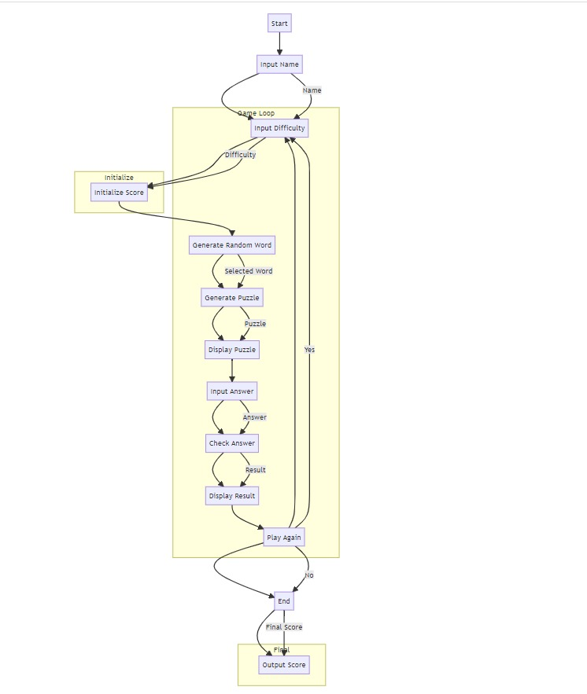

# FEATURES AND FUNCTIONALITY

Creating a crossword puzzle generator program in C involves various features and functionality to make it robust and user-friendly. Here are some essential features and functionality you can implement in a crossword puzzle generator program using C:

1. Grid Generation:

- Create an empty crossword grid with rows and columns.

- Ensure that the grid layout adheres to standard crossword puzzle rules (e.g., symmetrical layout).

2. Word Entry:

- Allow the user to input a list of words (clues and answers) to be used in the puzzle.

- Validate the input words for length and suitability within the grid.

3. Puzzle Generation:

- Automatically populate the crossword grid with words from the provided list.

- Implement an algorithm to fit words together while ensuring that they intersect at common letters.

4. Clue Generation:

- Generate clues for each word in the puzzle.

- The clues should be user-friendly and provide hints for solving.

5. Display:

- Create a graphical or text-based interface to display the crossword puzzle and clues.

- Allow the user to view the puzzle and clues simultaneously.

6. Interactivity:

- Implement user-friendly controls for navigating the puzzle grid.

- Allow users to click on grid cells to input their guesses.

7. Solving Mechanism:

- Implement a solving algorithm that checks whether the user's input matches the correct answer.

- Provide feedback on correctness (e.g., highlighting correct letters or cells).

8. Save and Load:

- Allow users to save their progress and resume playing later.

- Enable loading of saved puzzles.

9. Difficulty Levels:

- Offer different difficulty levels for generating puzzles (e.g., easy, medium, hard).

- Adjust the puzzle generation algorithm's complexity based on the chosen difficulty.

10. Timer:

- Implement a timer for users to track their solving time.

- Optionally, display a timer countdown for added challenge.

11. Scoring:

- Keep track of the user's score based on solving time and the number of clues solved.

- Display the user's score upon puzzle completion.

12. Hint System:

- Provide a hint system that gives users the option to reveal a letter or word for a penalty.

13. Validation:

- Implement validation checks to ensure that the crossword puzzle adheres to standard crossword rules.

14. Printing and Export:

- Allow users to print the puzzle or export it as a PDF or image.

15. Error Handling:

- Handle errors gracefully, such as incorrect inputs or unsolvable puzzles.

- Provide informative error messages.

16. User-Friendly Interface:

- Design an intuitive and user-friendly interface with clear instructions.

17. Randomization:

- Randomly shuffle word placements and clues to create different puzzles from the same word list.

18. Statistics and High Scores:

- Maintain statistics of past games and display high scores.

19. Cross-Platform Compatibility:

- Ensure the program is cross-platform compatible, if applicable.

20. Documentation:

- Include comprehensive documentation or help sections for users.

Implementing these features and functionality will result in a robust and engaging crossword puzzle generator program in C. Depending on the complexity of the program, you may need to use data structures, algorithms, and libraries to efficiently manage and manipulate crossword data.

# REQUIREMENT ANALYSIS

A crossword puzzle generator program in C code requires a detailed requirement analysis to ensure that it meets the expectations and needs of its users. Below is a list of key requirements for such a program:

1. User Interface:

- The program should have a user-friendly command-line or graphical user interface (GUI) for interaction.

- Users should be able to easily navigate the program, input preferences, and receive puzzle output.

2. Input Words:

- The program should allow users to input a list of words to be used in the puzzle.

- Optionally, the program can provide a dictionary or word list from which users can select words.

3. Puzzle Grid Generation:

- The program should generate an empty grid for the crossword puzzle.

- The grid should have adjustable dimensions based on the size of the words and the overall puzzle.

4. Word Placement:

- The program should intelligently place words into the grid, ensuring they intersect at certain points.

- Words should be placed horizontally and vertically, and they should not overlap or collide.

5. Clues Generation:

- The program should generate clues for each word in the crossword puzzle.

- Clues should be meaningful and solvable, providing hints for users.

6. Puzzle Constraints:

- Users should be able to set constraints on the puzzle, such as a minimum and maximum word length, and the orientation of words (horizontal, vertical, diagonal).

7. Difficulty Levels:

- The program can provide multiple difficulty levels for crossword puzzles, altering the complexity of word placement or the clues provided.

8. Validation:

- The program should validate generated puzzles to ensure they are solvable and adhere to crossword rules (no isolated letter grids).

9. Display and Printing:

- The program should display the crossword puzzle and clues for users to solve on the screen.

- Optionally, it should allow users to print the puzzle for offline solving.

10. User Interaction:

- Users should be able to input their answers for the crossword puzzle.

- The program should check user answers and provide feedback on correctness.

11. Scoring:

- Optionally, the program can keep track of user scores based on the time taken to solve the puzzle and the number of correct answers.

12. Save/Load Puzzles:

- Users should be able to save their progress on a puzzle and load it later to continue solving.

13. Cross-Platform Compatibility:

- The program should be designed to run on various operating systems (e.g., Windows, Linux, macOS).

14. Error Handling:

- The program should handle errors gracefully, providing informative error messages to users.

15. Documentation:

- The code should be well-documented, with clear comments explaining the logic and algorithms used.

16. Testing:

- The program should undergo rigorous testing to ensure the generation of valid puzzles and accurate functionality.

17. Performance Optimization:

- The program should be optimized for performance, especially when dealing with larger grids or word lists.

18. Security:

- If the program allows the uploading of word lists, it should include security measures to prevent malicious code execution.

19. License and Distribution:

- Define the license under which the program will be distributed (e.g., open-source, proprietary).

20. Usability and User Feedback:

- Collect user feedback to continuously improve the program's usability and features.

The above requirements form the basis for developing a crossword puzzle generator program in C code. Tailoring these requirements to specific user needs and considering additional features can further enhance the program's utility and user experience.

## Non-Functional Requirements:

Non-functional requirements (NFRs) for a crossword puzzle generator program using C code are essential for ensuring that the software meets certain quality attributes and constraints. Here are some non-functional requirements that might be relevant for such a program:

1. Performance:

- The program should generate crossword puzzles efficiently, with low latency.

- It should handle a large number of words and crossword grid sizes without significant performance degradation.

2. Scalability:

- The program should be scalable to accommodate crossword puzzles of various sizes and complexities.

3. Reliability:

- The program should be highly reliable, ensuring that generated puzzles are valid and solvable.

- It should handle errors gracefully, providing clear error messages to users when issues arise.

4. Availability:

- The program should be available for use whenever required without frequent downtime for maintenance or updates.

- Consideration should be given to backup and recovery mechanisms in case of system failures.

5. Security:

- If the program allows user-generated content (custom word lists, themes, etc.), it should implement proper input validation to prevent security vulnerabilities like SQL injection or buffer overflows.

6. Usability:

- The user interface should be intuitive and user-friendly, making it easy for users to generate crossword puzzles.

- Accessibility features should be considered to accommodate users with disabilities.

7. Compatibility:

- The program should be compatible with various C compilers and platforms to ensure wide usability.

8. Portability:

- The generated crossword puzzles should be exportable and printable in common formats (e.g., PDF, image) to make them accessible to a wider audience.

9. Maintainability:

- The source code should be well-documented, modular, and follow coding standards to facilitate easy maintenance and future enhancements.

10. Performance Optimization:

- The program should be optimized for memory usage to prevent excessive memory consumption.

- Code optimization techniques should be employed to enhance runtime performance.

11. Testing and QA:

- Comprehensive testing (unit testing, integration testing, etc.) should be performed to ensure the program's correctness and reliability.

- A quality assurance process should be in place to catch and fix bugs and issues.

12. Legal and Licensing:

- Ensure compliance with all relevant software licenses and intellectual property rights for any external libraries or data sources used in the program.

13.Documentation:

- Provide user documentation and technical documentation for developers to understand and use the program effectively.

14. Localization:

- If the program is intended for global use, support for multiple languages and character encodings should be considered.

15. Logging and Auditing:

- Implement logging and auditing mechanisms to record user actions and system events for troubleshooting and security purposes.

16. Resource Utilization:

- Ensure that the program utilizes system resources (CPU, memory, disk space) efficiently to avoid resource exhaustion.

These non-functional requirements are crucial for developing a reliable, efficient, and user-friendly crossword puzzle generator program in C code. Tailoring them to your specific project's needs and priorities is important for a successful software development process.

# CHALLENGES FACED

Developing a crossword puzzle generator program in C code can be a challenging task due to various complexities involved. Here are some common challenges you might face during the development process:

1. Word Database: Maintaining a comprehensive word database that includes words of various lengths, difficulty levels, and suitability for crossword puzzles can be challenging. The database needs to be regularly updated and managed.

2. Word Placement: Finding suitable positions for words in the crossword grid while ensuring that they intersect correctly with other words can be quite complex, especially for larger puzzles.

3. Grid Generation: Generating a crossword grid that adheres to design constraints (e.g., symmetry, grid size) while accommodating the chosen words is a non-trivial task.

4. Optimization: Optimizing the puzzle generation algorithm to create puzzles efficiently and quickly, especially for larger grids or when multiple puzzles need to be generated.

5. Clue Generation: Generating accurate and interesting clues for each word in the puzzle is a creative challenge. Clues should be challenging but solvable.

6. Symmetry and Aesthetics: Ensuring the crossword grid's symmetry and overall aesthetics can be challenging, as it requires careful placement of words and black squares.

7. Performance: Efficiently handling large datasets and grid generation operations can be computationally intensive. Ensuring that the program runs smoothly without consuming excessive resources is crucial.

8. User Interface: Creating a user-friendly interface for inputting word lists, specifying grid parameters, and displaying the generated puzzle can be challenging, especially if you want to create a user-friendly application.

9. Error Handling: Handling errors gracefully, such as when a grid cannot be generated for a given set of words or when there are conflicts in the crossword, is essential to provide a good user experience.

10. Testing and Validation: Thoroughly testing the crossword puzzle generator to ensure that it produces valid and solvable puzzles across different configurations and difficulty levels.

11. Randomness and Reproducibility: Balancing randomness and reproducibility in puzzle generation. You want puzzles to be unique, but you might also want to recreate specific puzzles for testing or distribution.

12. Crossword Grid Solvability: Ensuring that the generated crossword puzzles are solvable and don't have multiple solutions, which can be a complex constraint to enforce.

13. Memory Management: Managing memory efficiently, especially when dealing with large grids and word databases, to prevent memory leaks and crashes.

14. Scalability: Designing the program to be scalable for generating puzzles of various sizes and complexities.

15. Distribution and Licensing: If you plan to distribute your crossword puzzles, understanding and complying with licensing and copyright issues related to word lists and clues.

Addressing these challenges often requires a combination of algorithm design, data structure selection, and careful coding practices. Additionally, thorough testing and user feedback are essential to refine and improve the crossword puzzle generator program.

# CONCLUSION

In conclusion, developing a crossword puzzle generator program using C code presents a multitude of challenges that span the realms of data management, algorithm complexity, and user experience. Building a comprehensive word database, ensuring efficient word placement within a grid, generating symmetrical and aesthetically pleasing layouts, and crafting engaging clues demand both creative and technical expertise. Moreover, optimizing the program's performance while handling large datasets and addressing potential memory issues is a formidable task.

User interaction and interface design also play pivotal roles, as providing a user-friendly experience for inputting word lists, specifying puzzle parameters, and displaying generated puzzles is crucial. Beyond the technical aspects, ensuring the solvability and uniqueness of puzzles, addressing potential copyright concerns, and fine-tuning the generator based on user feedback are ongoing challenges. In tackling these complexities, developers must strike a balance between creativity and precision to deliver crossword puzzles that captivate users while upholding the standards of crossword puzzle design. It is a testament to the versatility of C programming that such challenges can be surmounted to create an enjoyable and intellectually stimulating experience for puzzle.